**PURBANCHAL UNIVERSITY**



**DEPARTMENT OF COMPUTER ENGINEERING**

**KHWOPA ENGINEERING COLLEGE  
LIBALI-2, BHAKTAPUR**

**A PROJECT REPORT**

**ON**

**FOOD FOR NEEDY**

A Report submitted for the partial fulfillment of requirements for the degree of Bachelor of Engineering in Computer Engineering (Fifth Semester)

**SUBMITTED BY**

Niru Kumari Mishra (740325)

Rabin Phaiju (740329)

Rodip Duwal (740334)

Roshan Dumaru (740335)

**UNDER THE GUIDENCE OF**

Er. Reena Manandhar

27 November 2020

**DEPARTMENT OF COMPUTER ENGINEERING**

**KHWOPA ENGINEERING COLLEGE  
LIBALI-2, BHAKTAPUR**

**CERTIFICATE**

This is to certify that the project entitled "FOOD FOR NEEDY" submitted by Ms. Niru Kumari Mishra, Mr. Rabin Phaiju, Mr. Rodip Duwal & Mr. Roshan Dumaru in a partial fulfillment of the requirements for the award of the Degree of Bachelor of Engineering in Computer Engineering of Purbanchal University, is a bonafide work to the best of our knowledge and may be placed before the examination Board for their consideration.

**Panel of Examiners:**

|  |  |  |
| --- | --- | --- |
| **Name** | **Signature** | **Date** |
|  |  |  |
|  |  |  |
|  |  |  |
| **External Examiner** |  |  |
|  |  |  |
| Er. …………………… |  |  |
|  |  |  |
| **Project Supervisor** |  |  |
|  |  |  |
| Er. ………………… |  |  |
|  |  |  |
| **Head of Department** |  |  |
|  |  |  |
| Er. …………………. |  |  |

|  |
| --- |
|  |

## **ACKNOWLEDGEMENT**

We are extremely grateful to Department of Computer Engineering, Khwopa Engineering College for providing us the opportunity to work on the project named **“Food For Needy”.** We would like to thank our project Supervisor Er. Reena Manandhar for her proper guidance and supportive attitude towards our project and giving us this opportunity to explore our abilities and knowledge in the field of computing. The intellectual assistance of all the other teachers for the preparation of this project is also hereby acknowledged.

**Project Team Members:**

Niru Kumari Mishra (740325)

Rabin Phaiju (740329)

Rodip Duwal (740334)

Roshan Dumaru (740335)

# List of Figures

|  |  |  |
| --- | --- | --- |
| **Fig no.** | **Title** | **Page** |
| 3.1 | Block diagram of “Food for Needy” | 3 |
| 3.2 | ER-Diagram | 4 |
| 4.1 | Landing page | 5 |
| 4.2  4.3  4.4 | Dashboard  Food Page  User-information Page | 6  7  7 |
| 4.5 | Content page | 8 |
| 4..6 | Message page | 8 |
| 4.7  4.8 | Admin page  User Dashboard page | 9  10 |
| 4.8 | Schedule page | 11 |
| 4.9 | Record page | 12 |

# List of Abbreviation

|  |  |  |
| --- | --- | --- |
| 1 | etc. | Etcetera |
| 2 | JS | JavaScript |
| 3 | MYSQL | Structured Query Language |
| 4  5  5 | PHP  Sass  SVG | PHP: Hypertext Preprocessor  Short for syntactically awesome style sheets  Scalable Vector Graphics |
|  |  |  |

# TABLE OF CONTENTS

**CONTENTS Page No**

**ACKNOWLEDGEMENT** ii

List of Figures iii

List of Abbreviation iv

TABLE OF CONTENTS v

CHAPTER 1 1

**INTRODUCTION** 1

**1.1 Background:** 1

**1.2 Statement of problem:** 1

**1.3 Objectives:** 1

**1.4 Application:** 1

**1.5 Scope**: 1

CHAPTER 2 2

**LITERATURE REVIEW** 2

CHAPTER 3 3

**METHODOLOGY** 3

**3.1 Background:** 3

**3.2 Generic Model** 3

**3.3 ER Model** 4

**4.2 Tools and Platform** 4

CHAPTER 4 5

RESULT 5

**Front-End:** 5

**Back-End:** 6

CHAPTER 5 12

**CONCLUSION AND RECOMMENDATION** 12

**5.1 Conclusion** 12

**5.2 Future Enhancement** 12

REFERENCES 13

# CHAPTER 1

## **INTRODUCTION**

### **1.1 Background:**

Food for Needy is web-based online platform that provide detail information related to food to its users. Indirectly, this project is created to manage wastage of food. Generally, there exist no such dedicated platform for food donation which provide a posting as well as communication facilities to its user.

Generally, most organization rely on their existing contact for communication and which are done formally using letters or Gmail which is quite unnecessary sometime. Donating and receiving food are limited to their limited area. Local group or individual were hardly involved in such activities. So, they all were limited to their own small area.

So in overall, this platform is a medium through which organization or a individual person, local group can relay the information related to food to another organization which in turns helps to reduce wastage of food, encourage local groups and individuals and enhance their area of contact.

### **1.2 Statement of problem:**

In general, there exist no such dedicated platform where food donating organization or individual person can relay their information. But they have to rely on their existing contact, so they were not aware of other than their existing one. But comparing some to relate-able project, we faced many problems regarding, how the interface is going to be and what feature are we capable of adding into it.

### **1.3 Objectives:**

The main objective of this project is to provide a dedicated platform where organization or individual person can communicate and relay information related to food to another organization which in-turns helps to reduce the wastage of food and encourage local effort too.

### **1.4 Application:**

This platform can be used by anyone I.e. from one individual person to an organization. As they can use this platform to relay their information about food and other details and also which will aware other needy organization about those individuals or organization. This project can also be used not just relaying information about food but it also provides a platform to communicate with other organization. Hence, providing a chatting system which is mail based.

### **1.5 Scope**:

The scope of our project “Food for Needy” is to provide an online platform for any one that may be any organization or individual person I.e. from local level to higher where they can relay information related to food by posting on site or through the short mailing platform which is available within this site. Hence encouraging local effort too.

# **CHAPTER** 2

## **LITERATURE REVIEW**

Actually, there are no such similar projects. So, for our project base we have taken reference from some relate able project and sites via internet. As this project is for relaying information and providing communication platform for its users.

Mailing project such Atmail, Zentyal, scandalo etc has provided a base for this project but these project does not contain a platform to post information and those projects was similar to Gmail. Hence, considering objective of this project, it lacks a posting platform and a quick mail sending platform.[1]

For Posting information, we had a glimpse to a quite popular site called hamrobazzar which is a marketing and management site. and which is quite similar to ebay. This site has provided us another base to work on.[2]

Hence, these site such as Atmail, Zentyal, scandalo and hamrobazzar has been a base of this project and combining some features of both we able to achieve our main objective and that is to provide a platform where organization or individual person can communicate and relay information related to food

# CHAPTER 3

## **METHODOLOGY**

### **3.1 Background:**

Regarding to development of this project various resources were collected via different site such as for the front end and back end design we have taken a glimpse from a site called Dribbble which provides just front end and back end images. For the features required by our project such as communication platform, scheduling system and displaying food info we looked deeply through some relate able site such as G-mail, Food for Life, Food Tank etc. For SVG design we have looked through unDraw.co, Animation on Scroll etc. For the map that we included in our project we used a git-library provided by GH Rahul via internet.

### **3.2 Generic Model**

Login

User

Admin

Adding food info

Making Schedule

Editing their profile

Communication

between user

Maintain record /data

User verification

fig.3.1 Generic Model of “Food for Needy”

### **3.3 ER Model**

Donor

Receiver

Sponsor

Volunteer

User

is a

Relay

Obtain

Data/Info

Visible to

fig.3.2 ER Model of “Food for Needy”

### **4.2 Tools and Platform**

As this project is web-based, so for the development of this project we have used different tools such as HTML, PHP, MYSQL, JS, CSS, Sass, Xampp and Bootstrap. And for the development of this project we have used different platform such as VS code & computer browser (Chrome, Brave).

# CHAPTER 4

## RESULT

The Result of this project is as expected that is to achieve its objectives which is to provide a platform where organization or individual person can relay information related to food to another organization which in-turns helps to reduce the wastage of food and encourage local or individual effort. So, the obtain details of this platform can be discussed as follows:

### **Front-End:**

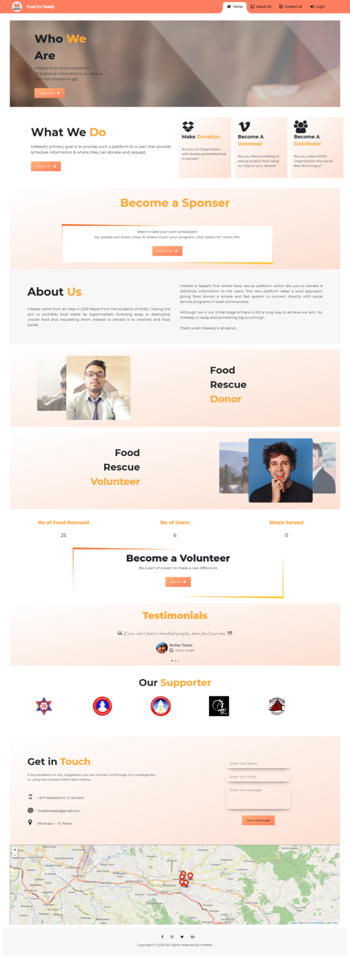

### **Back-End:**

#### Admin:

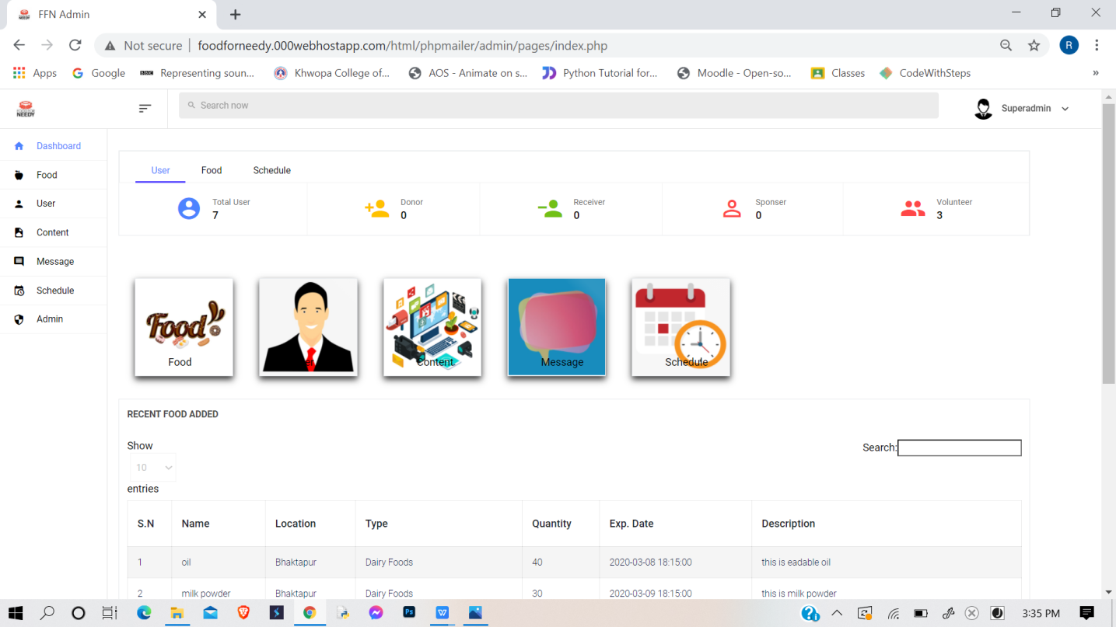

This is a dashboard of admin page which display the overall data in a summary. Such as showing number of user, messages, number of sponsor, volunteer etc.

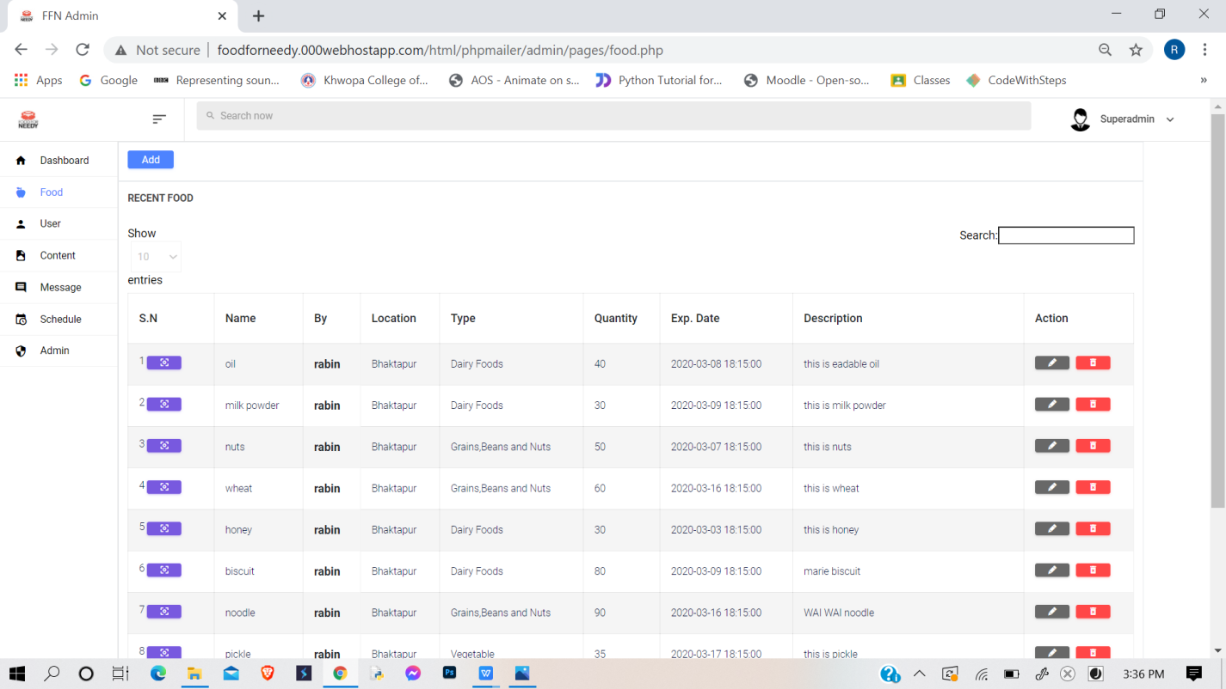

This page display details of food is provided by donor. Here one can perform auto search in their desire order like in alphabetical or in numeric.

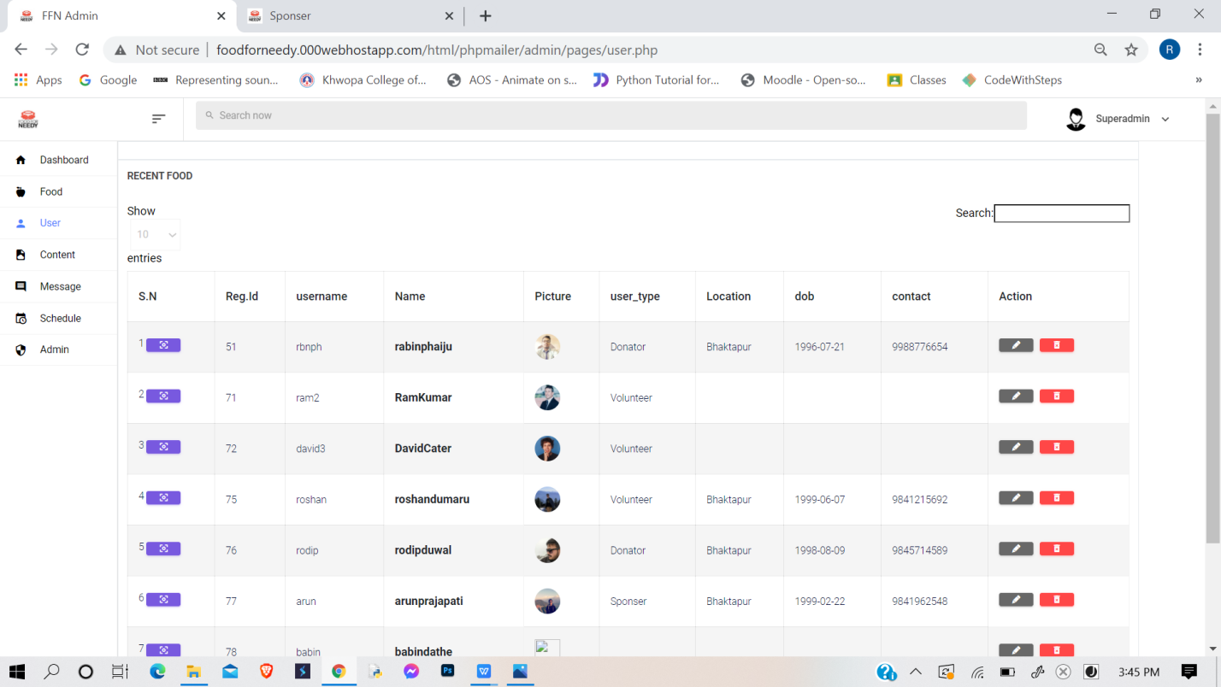

This page displays the detail information of all the user and admin can verify and update the user info.

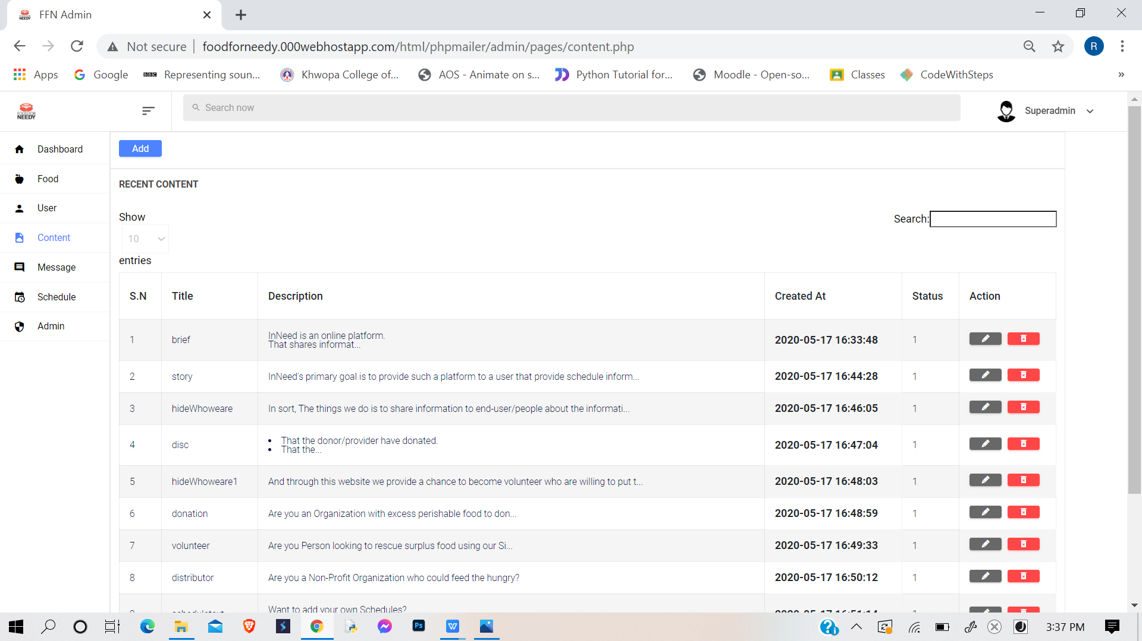

Here, this page displays all information that is displayed in front end page. And admin can edit, delete, update the front-end content without hard coding.

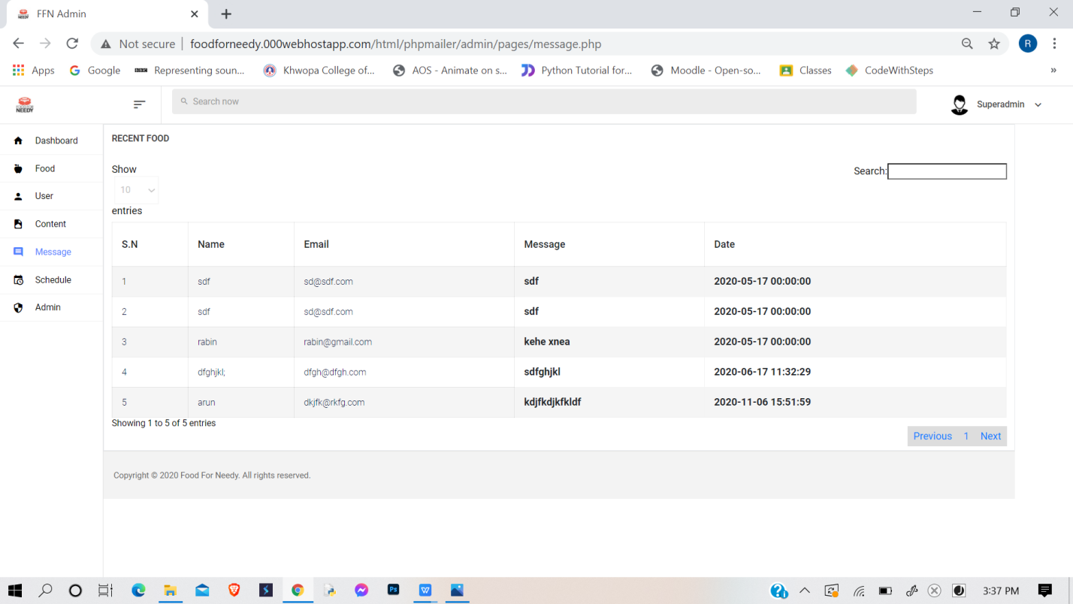

This page provides the message or suggestion provider by the user to admin.

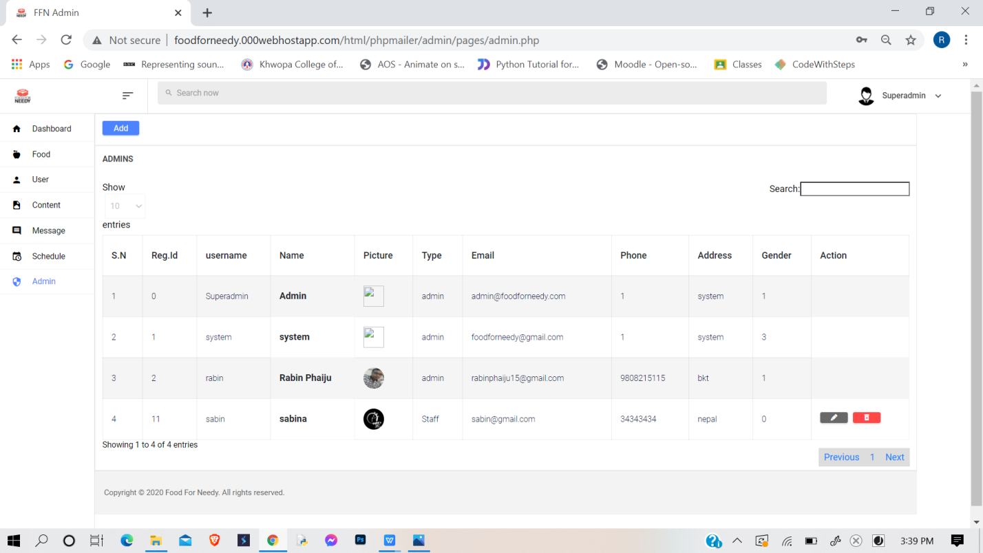

This page displays all the information of other admin except the password and other private details. Here a super admin can delete, update or edit the information of another admin.

#### User:

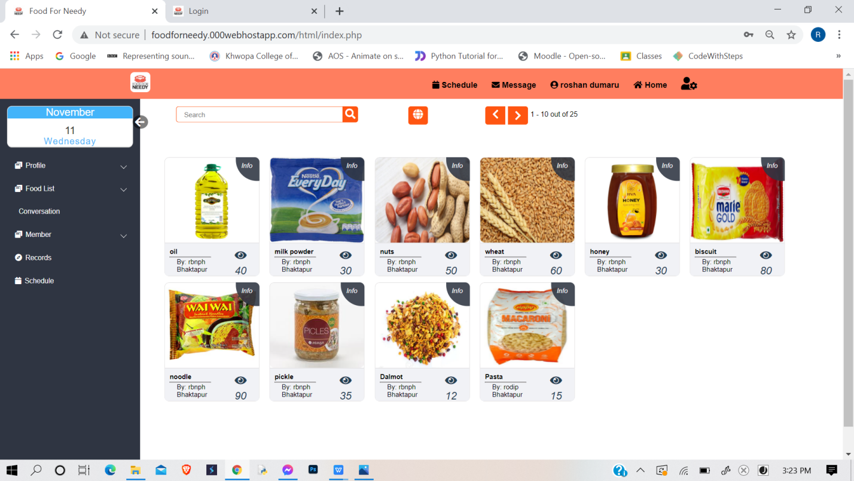

This is a dashboard for those users whose account exist in this platform. Here this page displays all the information about food that has been posted.

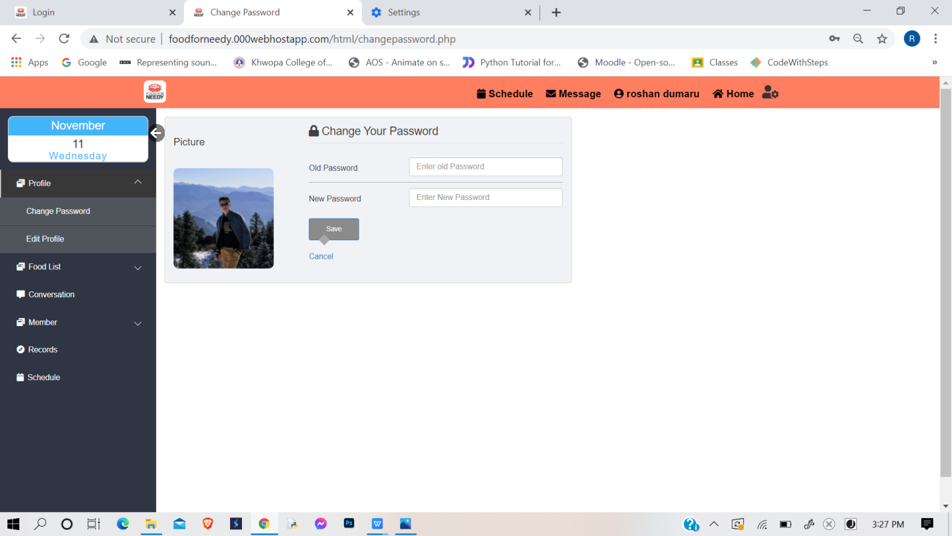

This page exist separately as most of user finds changing password to hard. Hence, this page allows user to change their password easily in case if they want to change their password.

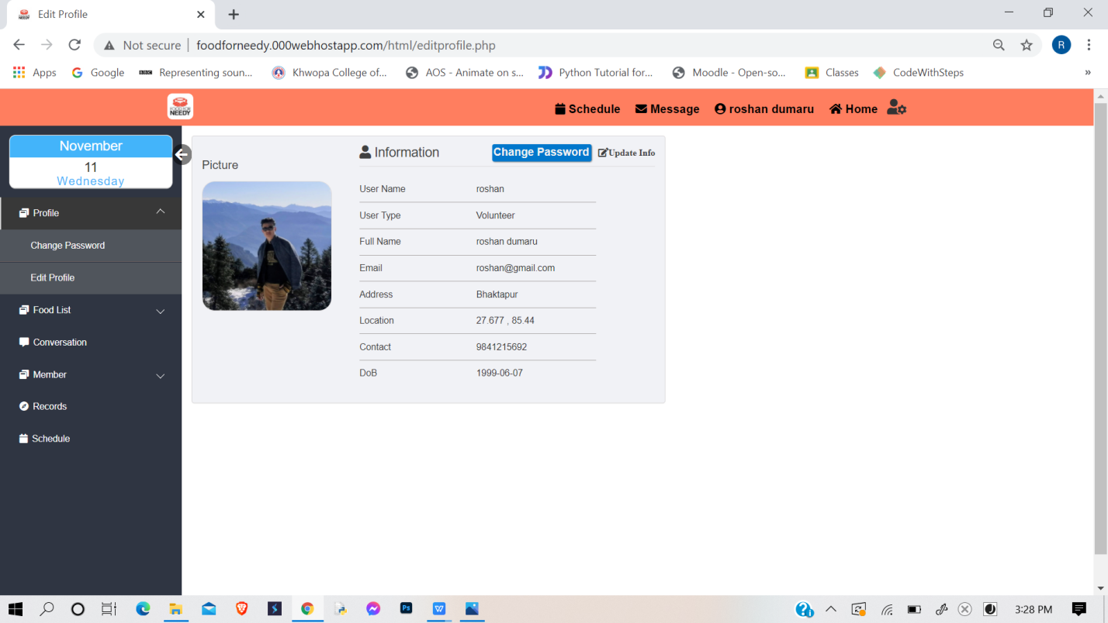

This page displays the detail information of his or her account and allows to edit or update their information.

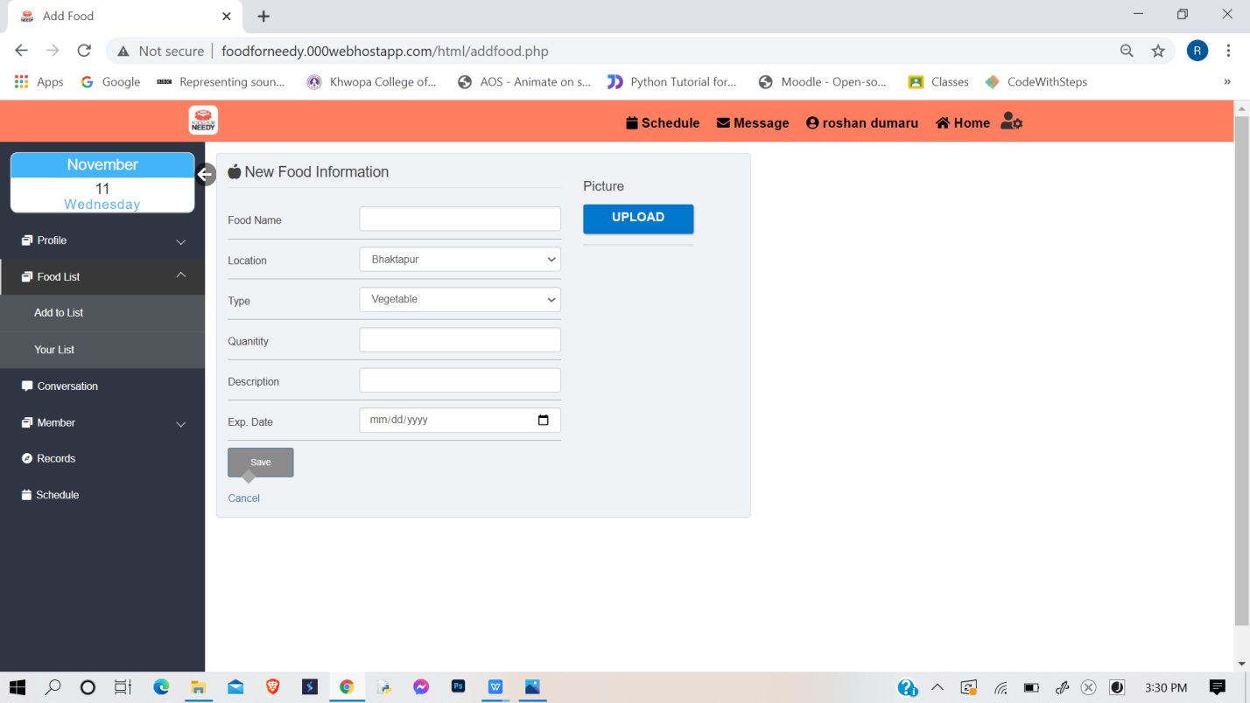

This page allows user to post or relay their information about food through this platform. So that other user can see them in their dashboard.

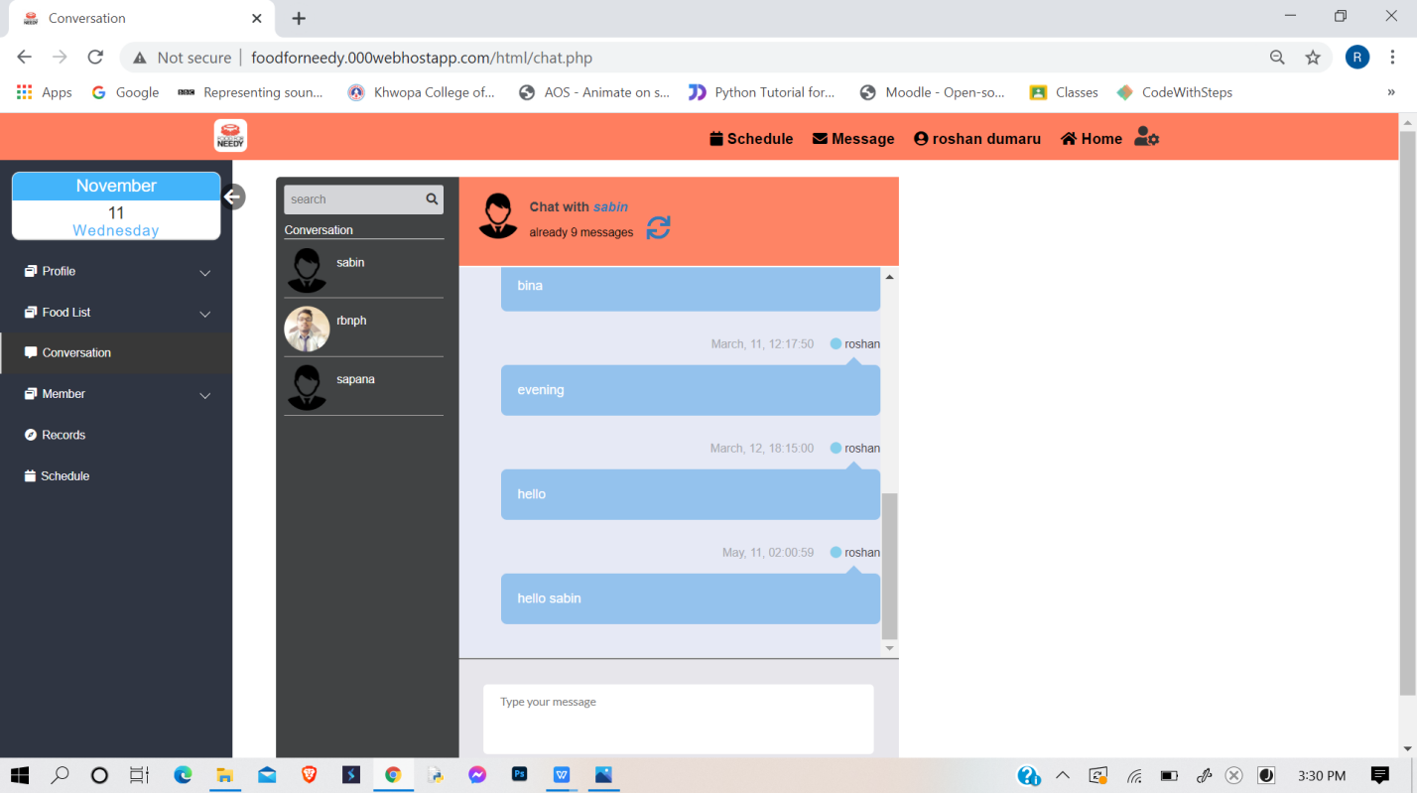

This is a communication platform. This communication platform allows user to communicate with each other in a mail based system. This platform exists as to eliminate excessive typing and for fast communication.

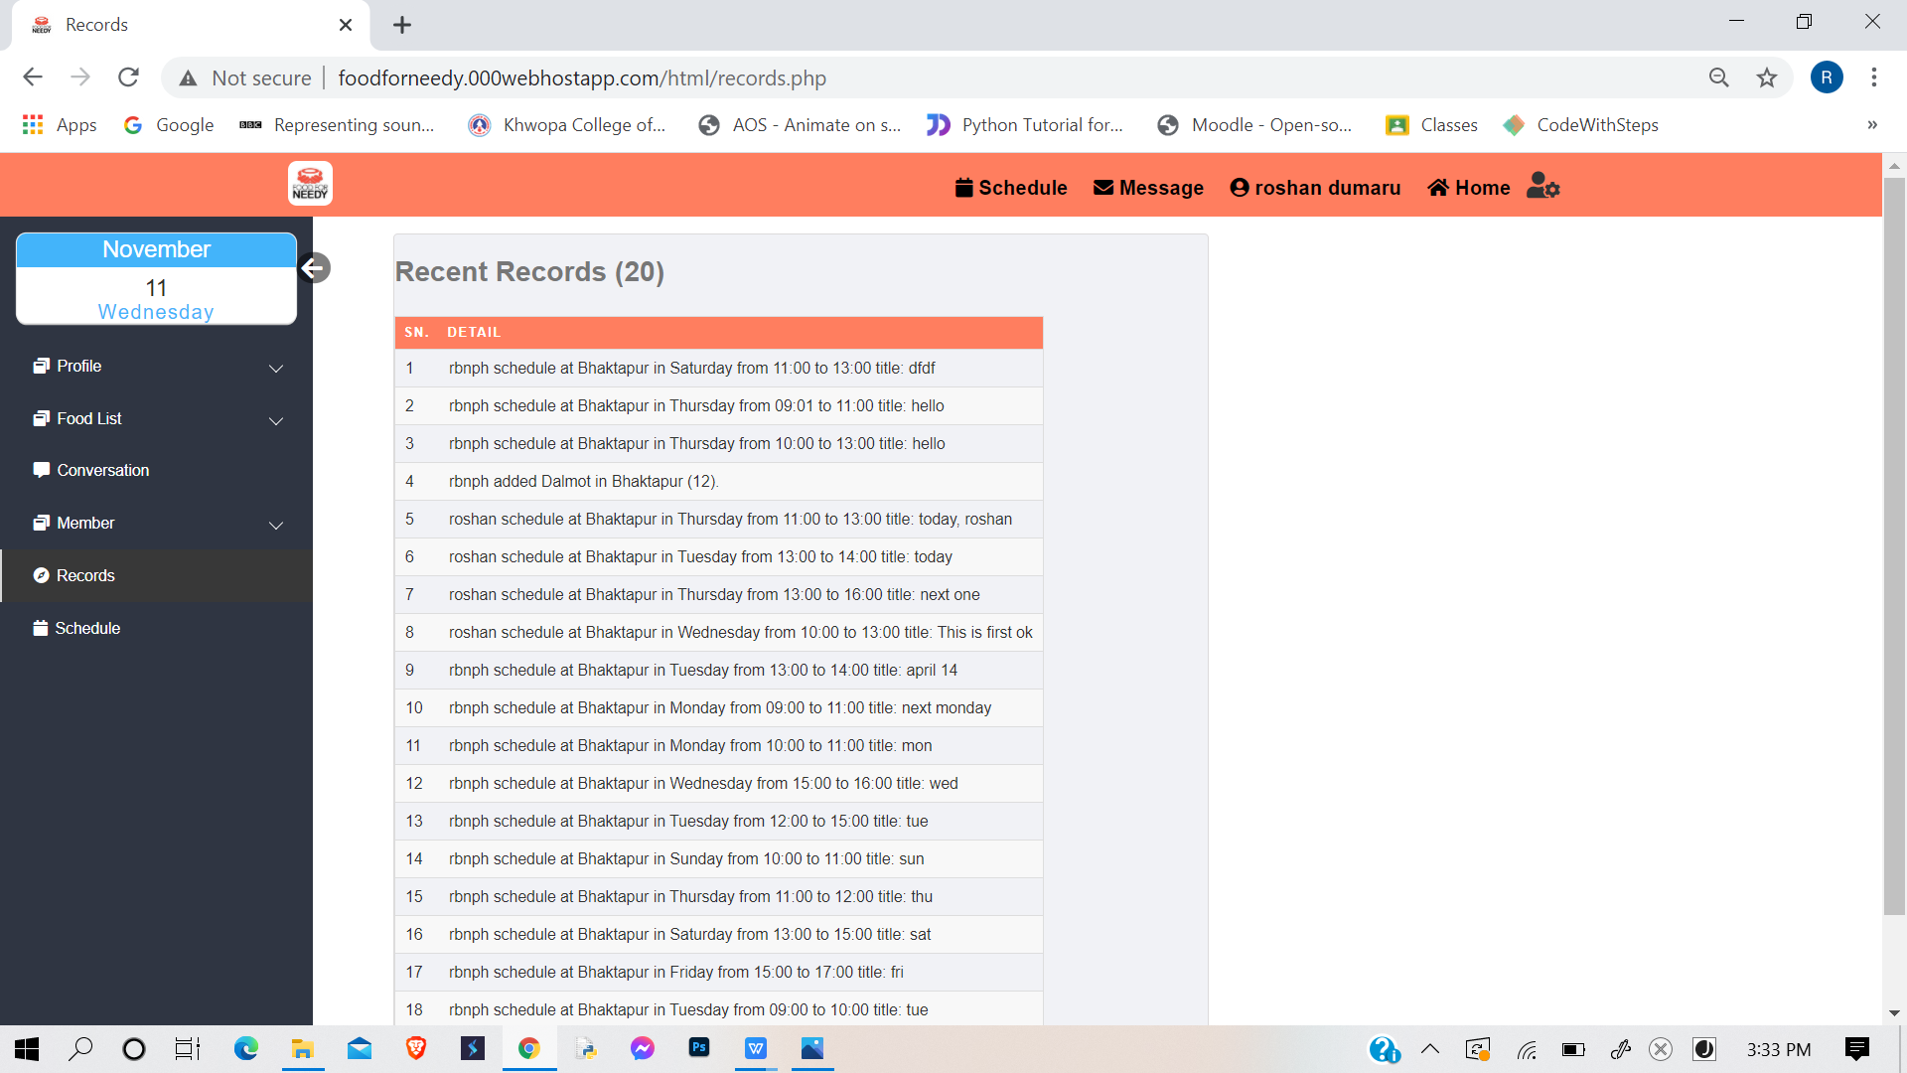

This page display recent 20 information posted by the users with details like their location, username, date and time etc.

# CHAPTER 5

## **CONCLUSION AND RECOMMENDATION**

### **5.1 Conclusion**

In completion of this project we got more familiar with the different programming language, scripting language and style sheet such as HTML, CSS, Sass, JS etc. As a whole, this project has been a good learning experience for us. We have gained knowledge about the various aspects of web designing and development. At the same time, we have developed a deep understanding about the data handling in databases.

In overall, we still want to emphasize that the program is not complete by itself. There are still lots of room for improvement. Pop up message could have made site more attractive and interactive. Short videos of gif could have made more attractive.

### **5.2 Future Enhancement**

This project can be very handy to many food donating organization and individuals as it provides a platform to communicate and to relay information. But for such handy project, it still some further enhancement such as:

1. Enhancing chatting system (making chat-based system rather than mail-based system)
2. Inserting Geo-location system
3. Adding more features like message pop up
4. Creating own API

# REFERENCES

[1] “Atmail, Zentyal, scandalo”, http://freshmeat.sourceforge.net/tags/mail-server [2014-06-1

[2] https://hamrobazaar.com/